Chapter 2 Arrays

Exercise 1:

WAP to write functions to perform the following operations:

1. insert()
2. del()
3. display()
4. reverse()
5. search()

Step 1: create an array arr that contains 5 ints

Step 2: The base address of this array is passed to functions like insert(), del(), display(), reverse() and search()

Step 3: The insert() function takes two arguments, the position pos at which the new number has to be inserted and the number num that has to be inserted:

Step 4: The del() function deletes the element present at the given position pos.

Step 5: In reverse(), we have to reverse the entire array by swapping the elements

Step 6: The search() function searches the array for the specified number.

Step 7: The display() function displays the elements of an array

Array: 11, 13, 14, 16, 1

Insert 444 in position 2: 11, 444, 13, 14, 16

Delete: del(arr, 5):11, 444, 13, 14, 0

Reverse: 0, 14, 13, 444, 11

Exercise 2:

WAP to Merge two arrays:

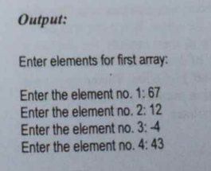

Read

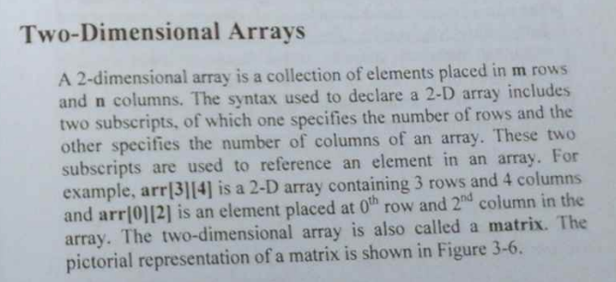

Q1

Q2

Q3

Q4

Output:

Read the below explanation after getting the right output

Q5

Q6

